2023 State Conference

Certificate of Participation
presented to

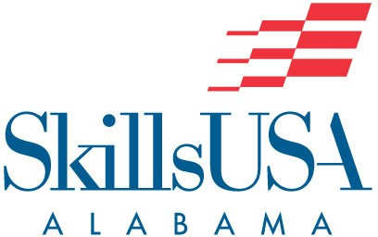
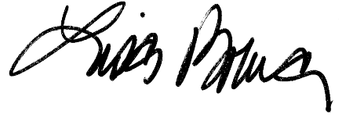
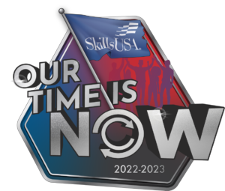

LISA BRUCE
Executive Director
4/26/2023
DATE

