2024 Southwest SkillsUSA Champions and Leadership Conference
Bishop State Community College
Time | Event | Campus | Building | Room
7:30 AM | Registration | Main | CAMTech | Lecture Hall Lobby
 |  | Carver | LRC/Library, Building M | Main Lobby
 |  | Southwest | Building N | Entry Foyer
9 AM | Contests Begin | Main | SEE CAMPUS LIST
 |  | Carver | SEE CAMPUS LIST
 |  | Southwest | SEE CAMPUS LIST
12 PM | LUNCH | Main | Evans Gymnasium | Concession area
1 PM | Awards Session | Main | Evans Gymnasium | Main Gym
2 PM | Conclusion | Main | Evans Gymnasium | Main Gym

MAIN CAMPUS CONTESTS
Parking: Main lot (M-F on map) for ALL Buses/Students
Congress Street Lot (M-A on map) for judges/guests in CAMTech
Parking Garage (S on map) for judges/guests in Kennedy Business Tech Center
Contest | Campus | Building | Room | MAP
Action Skills | Main | CAMTech | 218 | A
Class Project Display | Main | CAMTech | Lecture Hall 129 | A
Quiz Bowl | Main | CAMTech | 230/235 | A
Related Technical Math | Main | CAMTech | 238 | A
Job Skill Demonstration A | Main | CAMTech | 103/130/135 | A
Job Skill Demonstration Open | Main | CAMTech | 103/130/135 | A
Customer Service | Main | Health Sciences | 223/224 | C
Job Interview | Main | Ken Bus Tech | 208/211/212 | E
Prepared Speech | Main | Ken Bus Tech | 207/204 | E
Extemporaneous Speech | Main | Ken Bus Tech | 209/205/206 | E

CARVER CAMPUS CONTESTS
Buses should enter via the Redmond Street gate and circle through Lot C-D to drop off students.
Construction is in progress on this campus. Please adhere to posted signage and do not enter fenced areas.

Parking: Lot C-D on map. Buses should circle the lot and return to Main Campus after drop-off at Building M (Library). ￼
A Bishop State bus will be available to return students to Main Campus at noon for lunch. ￼
RETURN TO MAIN CAMPUS BY NOON

Contest | Campus | Building | MAP
Carpentry | Carver | H | H
Natural Hair Design | Carver | F | F
Cosmetology | Carver | F | F
Welding | Carver Welding | D | D
Welding Fabrication (Team of 3) | Carver Welding | D | D
Welding Beginner | Carver Welding | D | D

SOUTHWEST CAMPUS CONTESTS

Buses should enter campus through the Dauphin Island Parkway Main gate and drop contestants at C on the map and circle through parking lots SW-B/C to return to Main Campus.

Construction is in progress on this campus. Please adhere to posted signage and do not enter fenced areas.
Parking: Main lot (SW-B, SW-C on map) for ALL Buses/Students A Bishop State bus will be available to return students to Main Campus at noon for lunch. ￼
RETURN TO MAIN CAMPUS BY NOON

Contest | Campus | Building | MAP
Automotive Service Technology | SW | R | R
Electrical Construction Wiring | SW | M | M

We would like to give special recognition to the SPONSORS for this event:

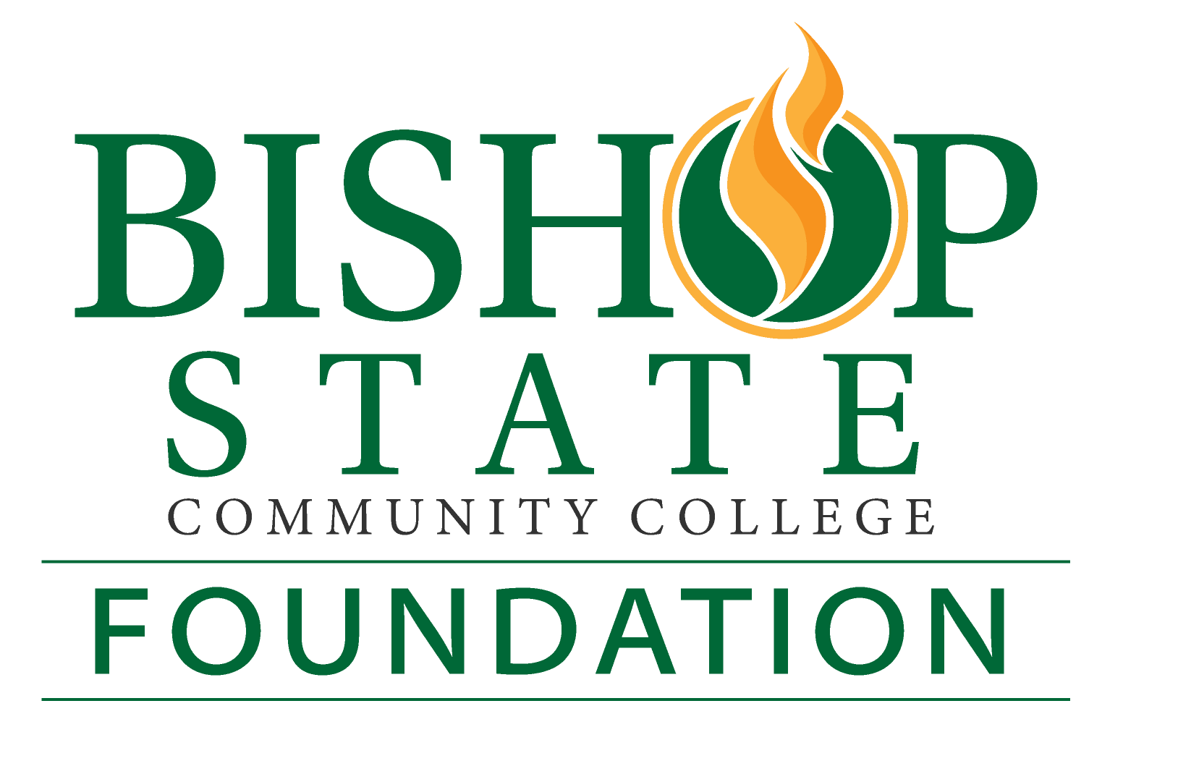
The Bishop State Community College Foundation funded LUNCH for the staff and participants.

