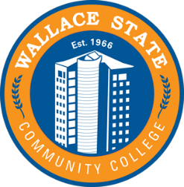
Central East Competition
Friday March 15, 2024
Wallace State Community College

Agenda
7:30-8:30 a.m. Registration- (School of Nursing & Science Center Frances Dodd Dr Hanceville AL 35077)
- Pick up Contestant Name badges
- Setup Displays in Lobby
9:00 a.m. Contests Begin

12:00 p.m. Contests Conclude (Judges submit scores)

12:00 p.m. Lunch

1:00 p.m. Awards Session

2:00 p.m. Conference Adjournment

Pickup displays and notebooks

